

*Scholar Green Primary School: Calculations Policy 2020*

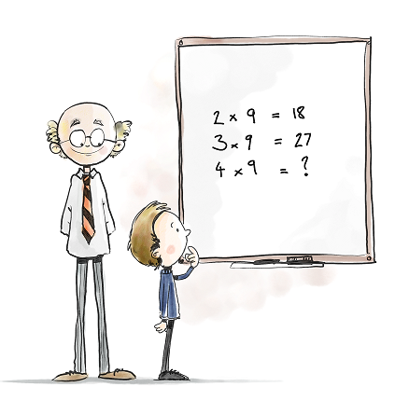

*Calculation Policy for Mathematics*

This calculation policy sets out the methods used to help our pupils with calculations and has been devised to meet requirements of the National Curriculum for the teaching and learning of mathematics and complements the progression documents for each year group. It is also designed to give pupils a consistent and smooth progression of learning in calculations across the school, taking into account White Rose Maths, the Mastery approach to maths used at Scholar Green Primary School.

The Calculation Policy shows methods that pupils will be taught within their respective year group, however it is split into each area of calculation: addition, subtraction, multiplication and division to show how the skills and knowledge are built upon progressively. Children should be confident in choosing and using a strategy that they know will get them to the correct answer as efficiently as possible; pupils are free to choose their preferred method to solve calculations.

**Concrete, Visual, Abstract**

A key principle behind White Rose Maths and Maths Mastery is based on the concrete, visual and abstract approach. Pupils are first introduced to an idea or skill by acting it out with real objects (a hands-on approach). Pupils then are moved onto the visual stage, where pupils are encouraged to relate the concrete understanding to pictorial representations. The final abstract stage is a chance for pupils to represent problems by mathematical notion. Whilst this calculation policy aims to show the CVA approach to the different calculations, it is not always noted further up the year groups. However, it is expected that the CVA approach is used continuously in all new learning and calculations even when not noted.

***Addition***

***Nursery***

In Nursery, pupils should be developing their concept of the number system through the use of **concrete materials.** They should show some curiosity about number and start to ask questions about numbers. This is where they are first introduced to number and by the end of Nursery they should be able to recite numbers in order up to 10. They should then be able to apply the number names during their play (perhaps in a number hunt).

Recite numbers up to 10 and compare group sizes

one, two, three, four, five, six, seven, eight, nine, ten

more, bigger, how many, count, same, total

**Counting**

Using concrete objects from their classroom: small world play, role play, counters, cubes etc they should be able to count how many objects are in a group. By the end of Nursery children should start to compare groups and say if groups have the same number of objects using words such as more, bigger or the same.

Children should also develop an understanding that actions: claps, jumps, steps can also be counted and not just objects.

**Numerals**

By the end of Nursery, children should be able to recognise the numerals up to 10 and point to them when questioned. They will begin to show numbers through actions, claps and showing on their fingers before beginning to write the numerals in a fun way and through play.

***Reception***

In Reception, pupils should be developing their concept of the number system through the use of **concrete materials and pictorial representations**. They should experience practical calculation opportunities using a wide variety of equipment, e.g. small world play, role play, counters, cubes etc. They develop ways of recording calculations using pictures, etc.

Count accurately up to 20, add two single digit numbers up to 10, counting on to find the answer and find one more than a certain number

add, more, make, sum, total, altogether, more, sum, one more, ten more.

Pupils must be provided with opportunities to develop their skills so that they are able to count reliably, including one to one correspondence and count on from a given number. Pupils should be given the opportunity to count out sets of objects and then combine them to make a total

e.g. 6 + 2 = 8

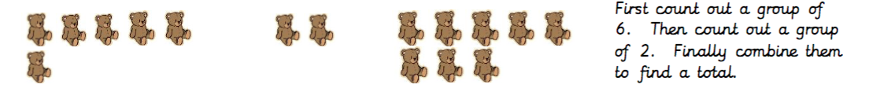

Pupils should recognise different ways of making numbers. E.g 6 can be made as

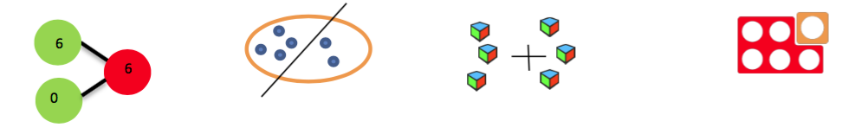

Children should be exposed to the + symbol in lots of fun practical ways and as part of continuous provision. They should have a clear understanding of what the symbol means and know it is made up of two perpendicular lines (although not exposed to this language). They could complete tracing activities for example in sand.

Once children are confident using concrete and pictorial representations, they can apply their knowledge of + symbol to write simple number stories.

**Year 1**

Add one-digit and two-digit numbers to 20, including zero

+, add, more, plus, make, sum, total, altogether, double, near double, one more, two more… ten more, greater, more, units, ones, tens, count, count (up) to count on (from, to) how many…?

Use objects to count on and add by using number bonds up to 20 and representing this using part, part, whole diagrams pictorially (dots) and abstractly (numbers) 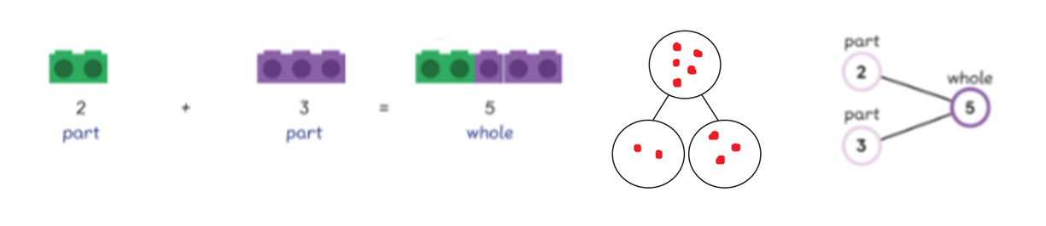

Use numbered number lines to add, by counting on in ones. Encourage children to start with the larger number and count on.

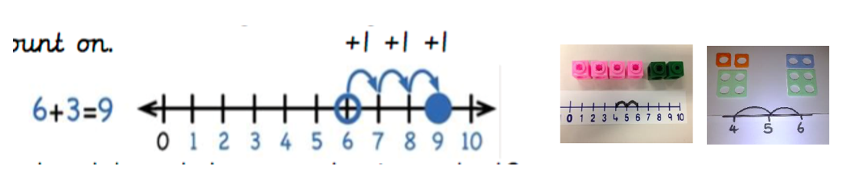

Using a bar model to support understanding of a number line to count on. 13 + 5 = 6 and to solve problems.

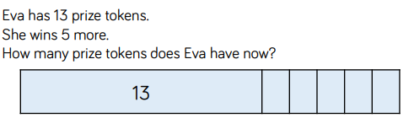

Regrouping to make 10 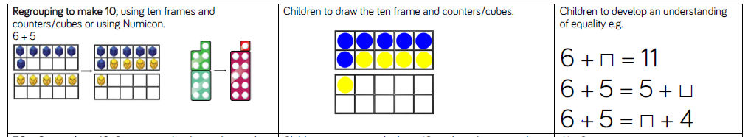

**Year 2**

Add with 2-digit numbers up to 100

+, add, more, addition plus, make, sum, total, altogether, double, near double, one more…, two more… ten more…, 100 more…greater, more, units, ones, tens, count, count (up) to count on (from, to) how many…?

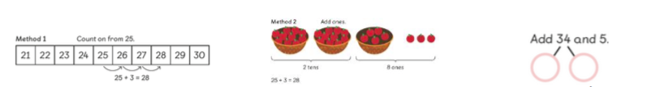Before moving onto the written method, children should add using a range of resources and methods.

Use a range of resources to add and associate to a written method (column method)

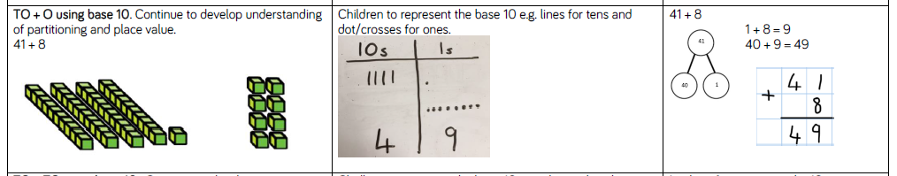

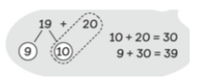Use knowledge of number bonds to add numbers

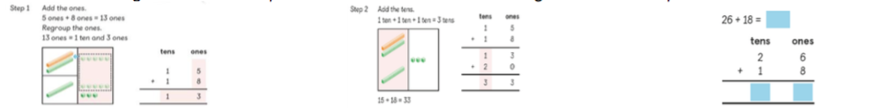When renaming, show the expanded method, but link straight to the compact method.

Children should use bars as a visual model to solve addition calculations and word problems.

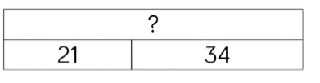

Children should knowthat addition of two numbers can be done in any order (commutative) and begin to use the inverse to check answers.

**Year 3**

Add numbers with 3 digits

+, add, more, addition plus, make, sum, total

, altogether, double, near double, one more…, two more… ten more…, 100 more…greater, more, units, ones, tens, count, count (up) to count on (from, to) how many…? Hundreds boundary.

Introduce the expanded column method using manipulatives (base 10 blocks or counters) first. Children must be given opportunity to do this for themselves practically

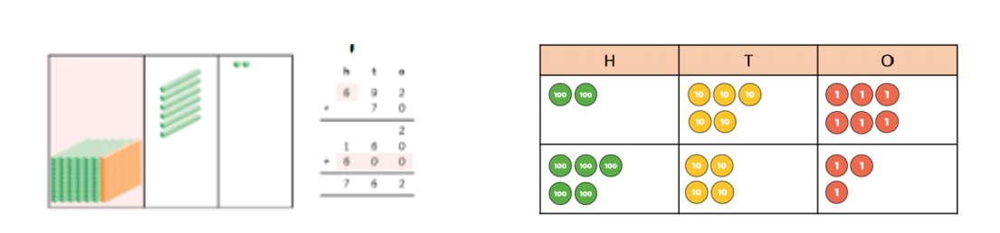

**Add the ones first in preparation for the compact method.**

Introduce addition with exchanging using the compact method with manipulatives (base 10 blocks or counters) first. Show how to exchange, with partitioning.

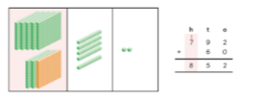 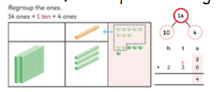

* Add the ones first.
* Carry the numbers directly above the **below** number, ensuring that the carried number is recorded first. (picture indicates above but our school policy is **below**).
* Once the exchanged number has been added on, cross out so children do not forget to add it on. (This should have been done physically first with concrete objects).
* The + symbol is positioned to the left, away from the digits

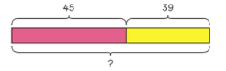Continue to use bars as a visual model to solve addition calculations and expose to word problems

**Year 4**

Add numbers with 4 digits

+, add, more, addition, increase, plus, make, sum, total, altogether, double, near double, one more…, two more… ten, more…, 100 more…greater, more, units, ones, tens, count, count (up) to count on (from, to) how many…? Hundreds, boundary, inverse.

Reinforce column method by using concrete materials first

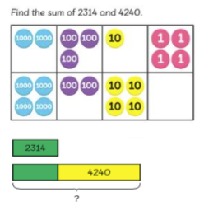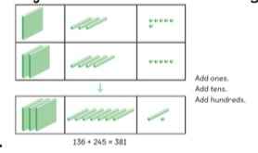

Move onto pictorial, using bar modelling.

Show expanded method to make link of place value. Move straight onto compact method. When exchanging, the number is carried directly below the number.

Use concrete materials to show exchanging.

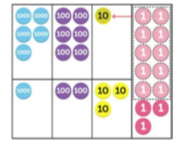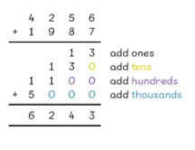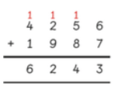

Children should be able to use the inverse to check their calculations.

**Year 5**

Add numbers with more than 4 digits

+, add, more, addition, increase, plus, make, sum, total, altogether, double, near double, one more…, two more… ten, more…, 100 more…greater, more, units, ones, tens, count, count (up) to count on (from, to) how many…?tens boundary , hundreds boundary, inverse, *units boundary, tenths boundary*

Carry on using methods taught in previous years to add, using the same terminology. Continue up to place value being taught.

Extend to numbers with at least five digits and include decimals. Add numbers with different amount of digits, e.g. 4 digit and 5 digit, presented horizontally, so children have to consider place value when setting out in column format)

3587 + 675 = 4262

23587

+ 4675

28262

1 1 1

If needed, 0 can be placed in empty place value columns to ensure digits place in the correct place but children must understand that they are not needed it just an aid for place value

When adding decimals, use place value counters to show addition and use when exchanging.

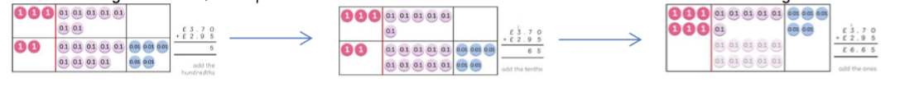Extend to up to two places of decimals (same number of decimals places) and adding several numbers (with different numbers of digits).

372.8

127.7

+ 54.6

555.1

Children should by now, be confident with the formal written method. Concrete or pictorial representations may be used to support children who need it or when introducing adding numbers with different amount of digits but would not be needed for each step.

Children should continue to use inverse to check answers. Children should begin to use rounding to check answers and should be able to know when an answer does not feel right because of their understanding on number and place value.

**Year 6**

Add numbers with more than 4 digits

+, add, more, addition, increase, plus, make, sum, total, altogether, double, near double, one more…, two more… ten, more…, 100 more…greater, more, units, ones, tens, count, count (up) to count on (from, to) how many…?tens boundary , hundreds boundary, inverse, *units boundary, tenths boundary*

Carry on using methods taught in previous years to add, using the same terminology. Continue up to place value being taught.

Extend to numbers with any number of digits and decimals with 1, 2 and/or 3 decimal places.

13.86 + 9.481 = 23.341

13.860

+ 9.481

23.341

1 1 1

Revert to expanded methods if the children experience any difficulty.

***Subtraction***

***Nursery***

separate a group of three or four objects in different ways, beginning to recognise that the total is still the same

one, two, three, four, five, six, seven, eight, nine, ten

less, smaller, how many, count, same, total

**Counting**

Using concrete objects from their classroom: small world play, role play, counters, cubes etc. they should be able to count how many objects are in a group. By the end of Nursery children should be able to separate a group of 3 of 4 objects in different ways and begin to recognise that the total is still the same. This should then allow then to have an interest in numbers and be something they can experience through their classroom and outdoor environment.

**Numerals**

By the end of Nursery, children should be able to recognise the numerals up to 10 and point to them when questioned. They will begin to show numbers through actions, claps and showing on their fingers before beginning to write the numerals in a fun way and through play. Throughout Nursery children should show an interest in numbers and numerals in their environment.

***Reception***

Using quantities and objects, subtract two single-digit numbers and count back to find the answer and find one less than a certain number

take (away), leave, how many are left/left over? how many have gone? one less, two less… ten less… how many fewer is… than…? difference between, is the same as

Pupils should count out a group of objects, move some away and recount the total.

8 – 3 = 5

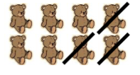

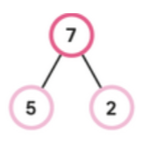After pupils have recognised different ways of making numbers, they should use this number bond knowledge to help with subtraction facts. Children should use concrete materials to start counting back in order to solve subtraction problems. 8 – 3 =

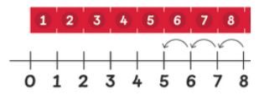

Children should be exposed to the - symbol in lots of fun practical ways and as part of continuous provision. They should have a clear understanding of what the symbol means and know it is made up of one horizontal line (although not exposed to this language). They could complete tracing activities for example in sand.

Once children are confident using concrete and pictorial representations, they can apply their knowledge of - symbol to write simple number stories.

**Year 1**

Subtract one-digit and two-digit numbers to 20, including zero

*-, subtract*, take (away), *minus*, leave , how many are left/left over? how many are gone? one less, two less, ten less… , how many fewer is… than…? *how much less is…?* difference between , *half, halve* , *=, equals, sign,* is the same as

Building on from the EYFS methods, children consolidate understanding of subtraction practically. Use physical objects to count back, which is then reinforced on different number squares and number lines.

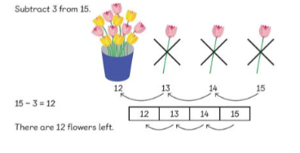

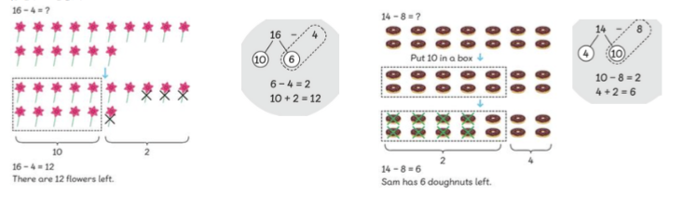Pupils use knowledge of place value to partition 2 digit numbers in order to subtract ones from the number. They will be exposed to language such as “How much more” and “What is the difference between”.

Pupils will be exposed to the idea of commutativity to understand the idea of fact families. 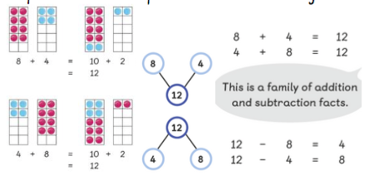

Children should start recalling subtraction facts up to and within 10 and 20, and should be able to subtract zero.

Use part-part-whole, bars and base ten to explore structure and answer missing number sentences:

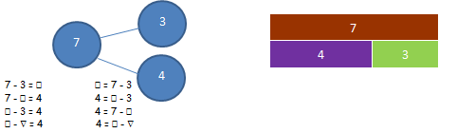

**Year 2**

Subtract: Subtract with 2-digit numbers

-, subtract, take away, minus, leave, how many are left/left over? ten less… one hundred less , how many less is… than…? how much fewer is…? difference between half, halve, =, equals, sign, is the same as, tens boundary, inverse

Before moving onto the written method, children should subtract using a range of resources and methods, including using knowledge of number bonds to subtract numbers.

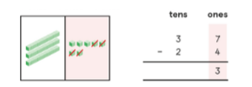Use knowledge of subtraction to take away groups of 10. 4 – 1 = 3 so therefore 40 – 10 = 30. Use a range of resources to add and associate to a written method (column method)

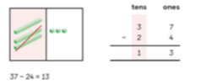

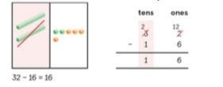When exchanging, you subtract the ones first, and then cross out the number you need to exchange from and write new number on top.

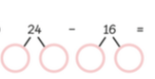 Use knowledge of number bonds to subtract.

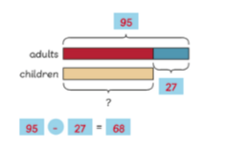Children should use bars as a visual model to solve subtraction calculations and exposed to word problems.

Children should also know that unlike addition, subtraction can only be done in a specific order. They should also begin to use the inverse to check their answers.

**Year 3**

Subtract numbers with 3 digits

-, subtract, take (away), minus   
leave, how many are left/left over? ten less… one hundred less , how many fewer is… than …? how much less is…? difference between, half, halve , =, equals, sign, is the same as , tens boundary, hundreds boundary, inverse

Children should use mental strategies to subtract 1 digit numbers and multiples of 10 and 100 from 3 digit numbers.

Introduce subtraction with no exchanging using the compact method with manipulatives (concrete objectives e.g. base 10) first.

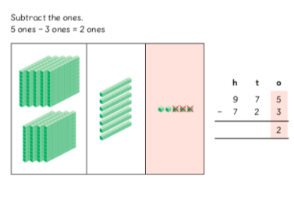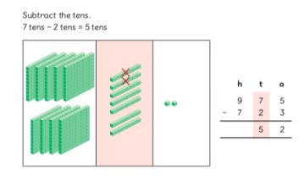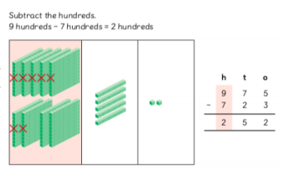

Show how to exchange, with partitioning.

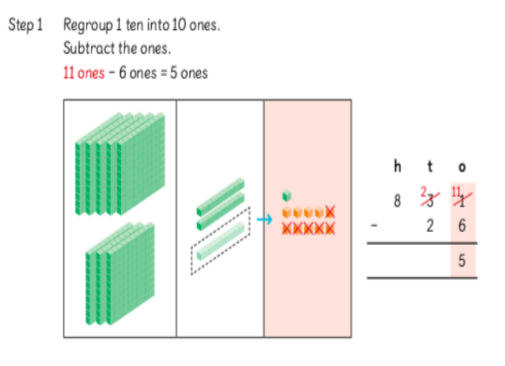

**Step 1**

* Exchange 1 ten into 10 ones
* Subtract the ones
* 11 one – 6 ones = 5 ones

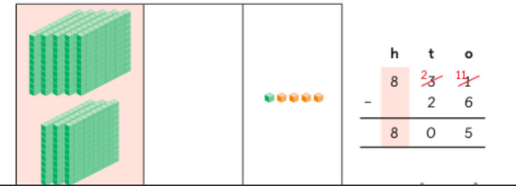

**Step 3**

* Subtract the hundreds
* 8 hundreds – 0 hundreds = 8 hundreds

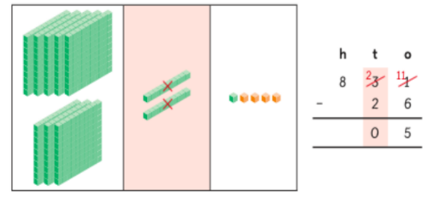

**Step 2**

* Subtract the tens
* 2 tens – 2 tens = 0 tens

The - symbol is positioned to the left, away from the digits

Carry on, introducing multi-step exchanging in single calculations.

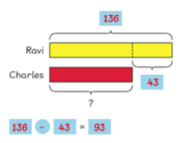Continue to use bars as a visual model to solve subtraction calculations and exposure to word problems.

**Year 4**

Subtract numbers with 4 digits

subtract, subtraction, take away, minus, decrease , leave, how many are left/left over? , difference between   
half, halve , how many more/fewer is… than…? , how much more/less is…? , is the same as, equals, sign , tens boundary,, hundreds boundary , inverse

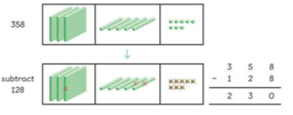Reinforce column method by using concrete materials first, including for renaming.

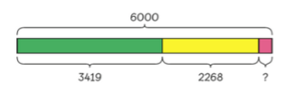

Move onto pictorial, using bar modelling.

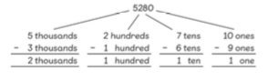Show expanded method to make link of place value. Move straight onto compact method.

When exchanging, the number is crossed out and rewritten directly above. Use concrete materials (such as counters) to show exchanging. Children to physically exchange the counters for themselves.

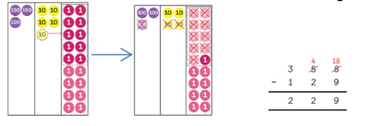

Children should be able to use the inverse to check their calculations.

**Year 5**

Subtract numbers with more than 4 digits

subtract, subtraction, take (away), minus, decrease, leave, how many are left/left over? difference between , half, halve , how many, more/ fewer is... than...? , how much more/less is...? , equals, sign, is the same as , tens boundary, hundreds boundary , *units boundary, tenths boundary*, inverse, rounding to estimate and check

Refine compact decomposition methods, ensuring method is being used for the right type of question, avoid using it for questions such as 3005 – 1897, as it is much more appropriate to use manipulation or counting on (as difference is small

4 1  5 1

Include where there is one zero on top line – but more than this and manipulation should really be used.

5 5 6 1   
 - 3 6 2 4

1 9 3 7

 When subtracting decimals, use place value counters to show subtraction and use when exchanging.

Children should continue to use inverse to check answers.

Children should begin to use rounding to check answers and should be able to know when an answer does not feel right because of their understanding on number and place value.

**Year 6**

Subtract numbers with more than 4 digits

subtract, subtraction, take (away), minus, decrease, leave, how many are left/left over? difference between , half, halve , how many, more/ fewer is... than...? , how much more/less is...? , equals, sign, is the same as , tens boundary, hundreds boundary , *units boundary, tenths boundary*, inverse

Carry on using previous methods taught in previous years to subtract, using the same terminology. Continue up to place value being taught.

Children will extend into using the decomposition method efficiently for decimals and large numbers, knowing when it is appropriate to use this method and when it is appropriate to count up or manipulate numbers.

e.g 21476 – 18739 (use column) 20008 – 19993 (count up) 14.3 – 10.92 (manipulate to 14.38 – 11.00)

**Multiplication**

**Nursery**

Know that numbers identify how many objects are in a set, shows an interest in number problems

pair, how many altogether, lots of, groups of

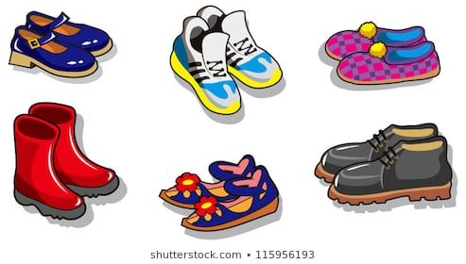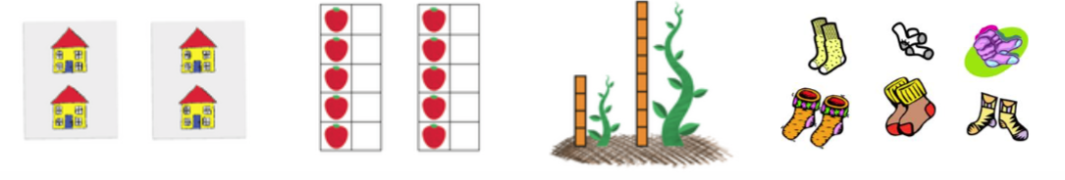Introduce children to the idea that some things come in groups or lots of them. Use practical items that the children will be familiar with and introduce to the word pair by looking at pairs of shoes or shocks. How many are there in a pair? How many pairs of things can you find?

By the end of Nursery, move on to looking at packets of things, e.g. multipacks of crisps to see how many there would be altogether and how things around the classroom come in groups. Hunt around the classroom to see how many groups of things they can find.

**Reception**

Solve problems, including doubling

‘lots of’, ‘doubling’

Children will experience equal groups of objects. They should work on practical problem solving activities.

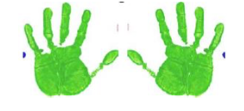

Use a range of concrete materials to show a number and then repeat the number to show doubling. Then move onto pictorial representations.



**Year 1**

Solve one-step problems involving multiplication by calculating the answer using concrete objects, pictorial representations and arrays

Lots of, groups of, multiply, times, add, steps of, jumps of, double

Children should practise making equal groups first and add them to associate repeated addition with multiplication. Use a range of concrete materials before pictorial representations.

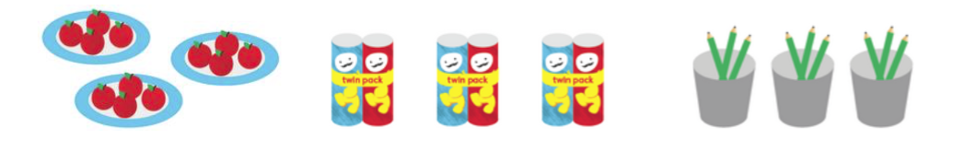

Associate grouping to equal rows so children learn to count up in the same number.

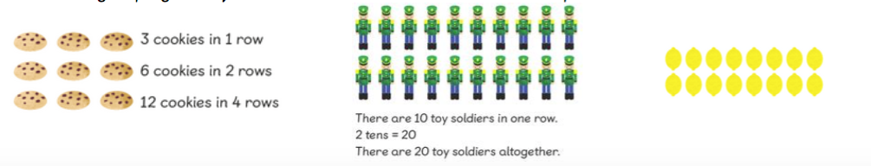

Use arrays (with concrete objects and pictorially) to begin to show multiplication with adult support where needed.



**Year 2**

Calculate mathematical statements and solve problems for multiplication within the multiplication tables (2, 5 & 10 – these to be taught explicitly and assessed regularly to ensure rapid recall)

lots of, groups of *,* x, times, multiply, multiplied by *,* multiple of *,* once, twice, three times, four times, five times… ten times… *,* times as (big, long, wide and so on) *,* repeated addition *,* array *,* row, column, odd and even numbers

Begin with consolidating Year 1 repeated addition and associate to multiplication. 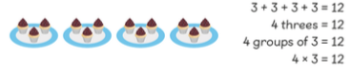

Before moving onto the written method, children should add using a range of resources and methods

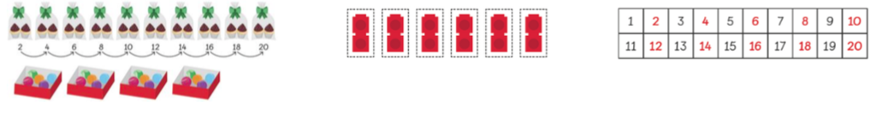

Children will associate the law of commutativity to multiplication using arrays and practical resources to show.

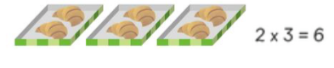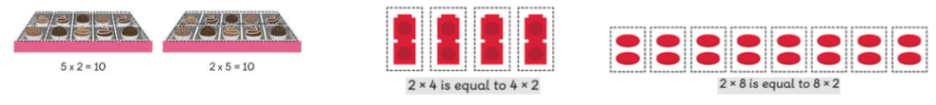

Move onto abstract route with problems.

**Include bar models to represent multiplication:**

I have 3 packs of 6 eggs. How many eggs altogether?

6 6 6

|  |  |  |
| --- | --- | --- |
|  |  |  |

Missing number calculations to apply and consolidate children’s understanding of multiplication

1) 3 x ⬜ = 12 2) ⬜ x 4 = 20 3) 2 x 2 + ⬜ = 10 4) ⬜ x 3 – 2 = 7   
  
5) ⬜ x 2 = 5 x 4 6) ⬜ x ⬜ = 3 x 4 7) ⬜ x 2 = 4 x ⬜

**Year 3**

Multiply 2-digits by a single digit number and solve problems for multiplication within the multiplication tables (3, 4 & 8 – these to be taught explicitly and assessed regularly to ensure rapid recall)

lots of, groups of , x, times, multiplication, multiply, multiplied by, multiple of, product, once, twice, three times, four, times, five times… ten times… , times as (big, long, wide and so on) , repeated addition, array, row, column

Introduce by applying already known knowledge to multiples of 10. Use a range of manipulatives to show. 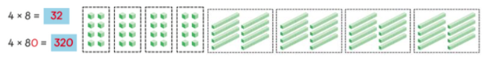

Consolidate repeated addition before moving onto multiplication of 2 digit numbers.

* Multiply the ones digit by the single-digit number.
* Multiply the tens digit by the single-digit number

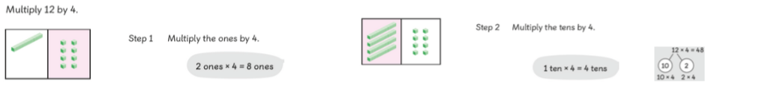Show partition to show how this looks, using manipulatives as a supporting mechanism. Show column method alongside.

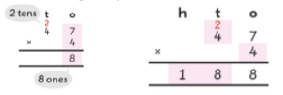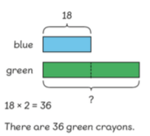Show expanded method for conceptual understanding, but move straight onto the compact method using same techniques and break-downs. Although shown above in picture, when writing the “carried over” tens, we will write underneath the answer line.

Continue to use CPA approach and visual bars when solving multiplication and division in word problems.

Missing number calculations to apply and consolidate children’s understanding of multiplication

1) 3 x ⬜ = 12 2) ⬜ x 4 = 20 3) 2 x 2 + ⬜ = 10   
  
4) ⬜ x 2 = 5 x 4 5) ⬜ x ⬜ = 3 x 4 6) ⬜ x 2 = 4 x ⬜

**Year 4**

Multiply 2 and 3-digit numbers by a single digit; teach explicitly and assess regularly the 6, 7, 8, 11 and 12 and use all multiplication tables up to 12x12

(ensure there is rapid recall of all multiplications)

lots of, groups of , times, multiplication, multiply, multiplied by , multiple of, product , once, twice, three times , four, times, five times… ten times , times as (big, long, wide, and so on) , repeated addition , array , row, column

Pupils should continue to develop their knowledge and understanding of multiplying by a single digit, using short multiplication (the formal written method of compact multiplication).

Show expanded method but move straight onto compact method, as in Year 3, to show why and how to carry over.

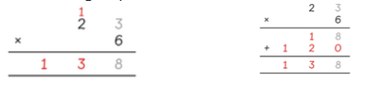

Use different CPA approaches to show the same calculation.

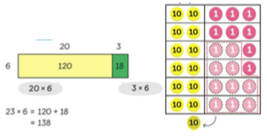

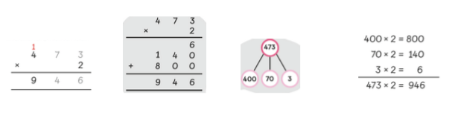Pupils must be secure in multiplying a 2-digit number by a single digit, before moving onto 3-digit numbers. Repeat using same process as 2-digit numbers.

Depth of understanding: children should also be able to answer missing box questions.

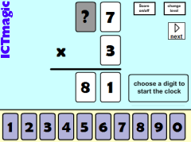

**Year 5**

Multiply numbers up to 4 digits by a one- or two-digit number

lots of, groups of, times, multiplication, multiply, multiplied by , multiple of, product , once, twice, three times   
four times, five times… ten times , times as (big, long, wide, and so on) , repeated addition , array, row, column

Carry on using previous methods taught in previous years to multiply, using the same terminology. Continue up to place value being taught. Start with 4 digits multiply by 1 digit before slowly adding further digit.

Continue short multiplication ThHTU x U and TU.ths x U (with numbers up to 2 decimal places).

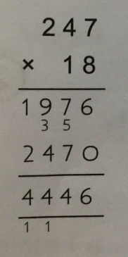Moving on to:

238

X 7

1666

2 5

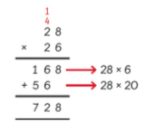

**0**

**Place Holder**

When multiplying by the tens number, place a 0 in the ones column. This is to be explained to the children as a place holder and it makes the number ten times bigger by moving each digit up a place value column.

Use knowledge of relationships to manipulate multiplication:

e.g. I know that 16 x 4 = 8 x 8 or 25 x 48 = 50 x 24 = 100 x 12

24 x 15 = 12 x 30 = 360

36 x 16 = 72 x 8 = 576

⬜ x 25 = 64 x 100

162 x ⬜ = 81 x 30

**Year 6**

Multiply multi-digit numbers up to 4 digits by a two-digit whole number

lots of, groups of, times, multiplication, multiply, multiplied by , multiple of, product , once, twice, three times   
four times, five times… ten times , times as (big, long, wide, and so on) , repeated addition , array, row, column

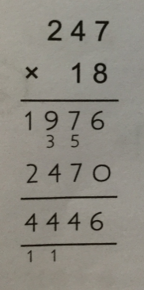Carry on using previous methods taught in previous years to multiply, using the same terminology. Continue up to place value being taught. Start with 4 digits multiply by 1 digit before slowly adding further digit.

When multiplying decimals, use same method but ensure decimal point is in with all values carefull y written, in line, on either side.

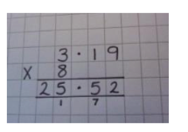

**Division**

**Nursery**

Know that numbers identify how many objects are in a set, shows an interest in number problems

pair, lots of, groups of, share

Use practical items that the children will be familiar with and introduce the idea that things can be shared out. Think about the word pair from multiplication and recap learning here. We share each shoe or sock between each foot.

By the end of Nursery, move on to sharing out more items, this could be done with snack time. Count out the apples and count them out as they are shared between the children in the class. This is the very beginning of division and the word shared should be used rather than divide or division.

**Reception**

Solve problems, including halving and sharing

share, share equally, sharing, groups of, how many groups? halving

Pupils should have many practical experiences of sharing objects e.g. sharing between 2 people, or finding ½ of a group of objects.

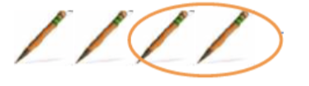

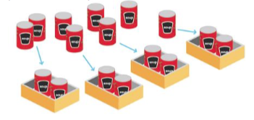Use a range of concrete materials to show a number and then share them equally. Then move onto pictorial representations.



**Year 1**

Solve one-step problems involving division by calculating the answer using concrete objects, pictorial representations and arrays

share, share equally, groups of, divide, how many groups? half

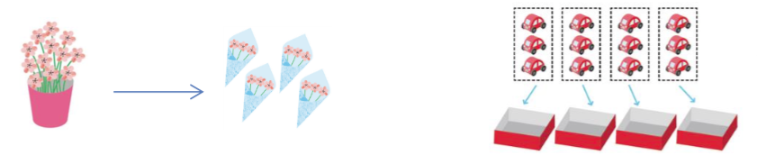Building on multiplication knowledge and EYFS division strategies, children practise grouping concrete objects equally in order to count the amount in each group. Use a range of concrete materials before pictorial representations.

Build on practical materials by sharing and moving objects.

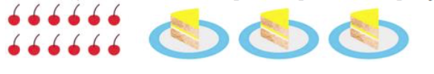

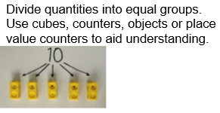

**Year 2**

Calculate mathematical statements and solve problems for division within the multiplication tables (2, 5 & 10)

double, halve , share*,* share equally *,* one each, two each, three each… group in pairs, threes… tens *,* equal groups of *,* ÷, divide, divided by, divided into, left, left over, odd and even numbers

Build on Year 1 by consolidating grouping equally. Use a range of resources to show division.

Work on each times table in order (2, 5 then 10). Use idea of grouping before show division and link to the abstract calculation with the ÷ sign.

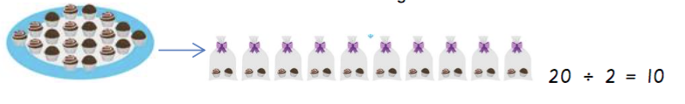

Associate to the law of commutativity to show link between multiplication and division.

C:\Users\jfrankland\OneDrive - rodeheath\Rode Heath\Subject Leader\Maths\Calc 19\Year 2\Screen Shot 2019-01-30 at 20.55.23.png

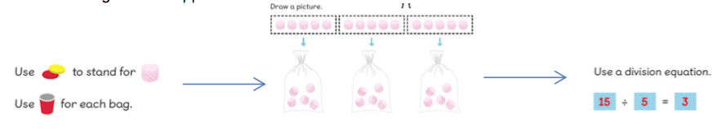**Work through CPA approach.**

**Using symbols to stand for unknown numbers to complete equations using inverse operations**

□ ÷ 2 = 4 20 ÷ △ = 4 □ ÷ △ = 4

Children need to understand that **even** numbers divide equally by 2 with none left over and **odd** numbers will have one left over when divided by 2.

**Year 3**

Divide 2-digit numbers by a single digit (where there is no remainder in the final answer)

double, halve , share, share equally , one each, two each, three each… group in pairs, threes… tens , equal groups of , ÷, divide, division, divided by, divided into, left, left over, remainder

Introduce division by using manipulatives to divide (working on times table in order – 2, 5, 10, 3, 4, 8). Show partitioning to link in division.

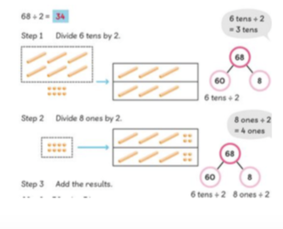

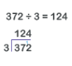Introduce the “Bus Stop” method to give the children an alternative method for short division. Multiples of the divisor can be written vertically to help with the calculation.

Use base ten and place value counters to support understanding of “Bus Stop” division where needed.

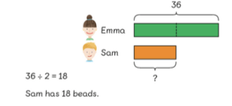Continue to use CPA approach and visual bars when solving multiplication and division in word problems.

48 ÷ 6 = ⬜

⬜ x 6 = 48

48

|  |  |  |  |  |  |
| --- | --- | --- | --- | --- | --- |
| **?** |  |  |  |  |  |

**Year 4**

Divide up to 3-digit numbers by a single digit

double, halve , share, share equally, one each, two each, three each….group in pairs, threes… tens , equal groups of , divide, division, divided by, divided into, divisible by , remainder , factor, quotient *,* inverse

Pupils should continue to develop their knowledge and understanding of dividing by two-digits, short division. Move onto 3-digit using same approach.

‘Bus Stop’ method to give the children an alternative method for short division. Multiples of the divisor can be written vertically to help with the calculation.

If there is a remainder, this should be noted after the quotient.



Use base ten and place value counters to support understanding of “Bus Stop” division where needed.

**Year 5**

Divide at least 4 digits by single-digit numbers

double, halve , share, share equally , one each, two each, three each… , group in pairs, threes… tens , equal groups of , divide, division, divided by, divided into, *divisible by* , remainder , *factor, quotient , inverse*

Carry on using previous methods taught in previous years to divide, using the same terminology. Continue up to place value being taught. Start with 4 digits divide by 1 digit before slowly adding further digit.

Continue using the ‘Bus Stop’ method.

Multiples of the divisor can be written vertically to help with the calculation.



Move on to long division method as a more efficient method without remainders:

If there is a remainder, this should be noted after the quotient.

Use base ten and place value counters to support understanding of “Bus Stop” division where needed.

**Year 6**

Divide up to 4 digits by a two-digit

double, halve , share, share equally , one each, two each, three each… , group in pairs, threes… tens , equal groups of , divide, division, divided by, divided into, *divisible by* , remainder , *factor, quotient , inverse*

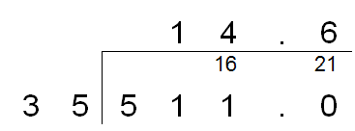C:\Users\jfrankland\OneDrive - rodeheath\Rode Heath\Subject Leader\Maths\Calc 19\Y56\Screen Shot 2019-01-30 at 21.08.13.png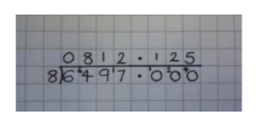Carry on using previous methods taught in previous years to divide, using the same terminology. Continue up to place value being taught. Start with 4 digits divide by 1 digit before slowly adding further digit. Teach how to express a remainder as a decimal and as a fraction.

Continue with partitioning where necessary for mental calculation.

136 ÷ 25

= 272 ÷ 50

= 544 ÷ 100 = 5.44

27 ÷ 1.5 = 54 ÷ 3

Carry on using long division method, introduce remainders:

