Year One – Spring 1 2021

Reading

Learning to read and spell more of the YR1 common exception words.

push, pull, full, house, some, where & there.

Maths – 2D and 3D shapes, Place Value and Addition & Subtraction

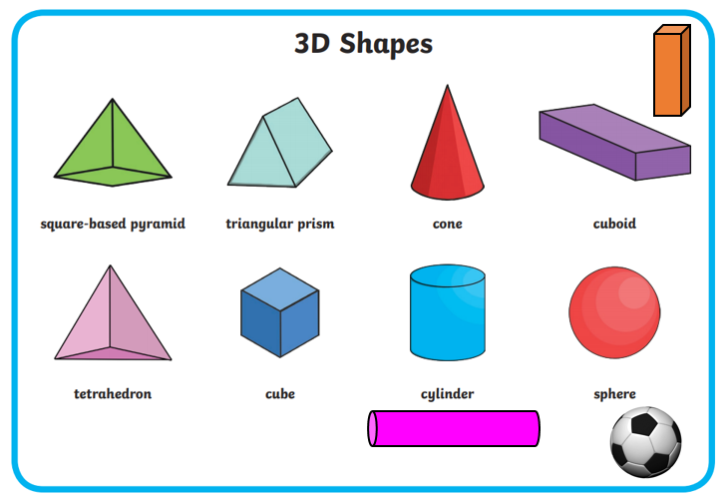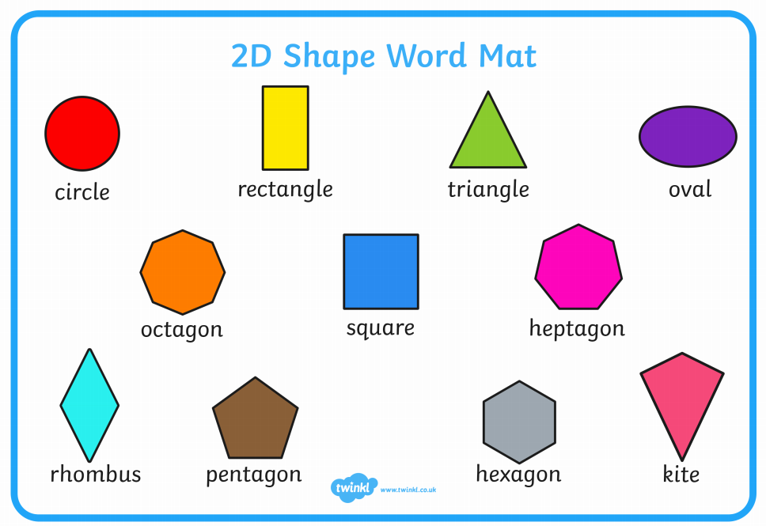 Knowledge Organiser

**Vocabulary**

Add, subtract, equals, capital letter, full stops, finger space, Shabbat, North Sea, Irish Sea, Bristol Channel, English Channel, 3D shape names & names of different materials.

Writing

We are continuing to have a focus on handwriting and forming our letters correctly.

All letters, *except capital letters*, must start with a lead in or get ready stroke.

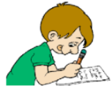

Geography To know the name of the seas surrounding the UK.

Science

**Materials**

**and their**

**properties.**

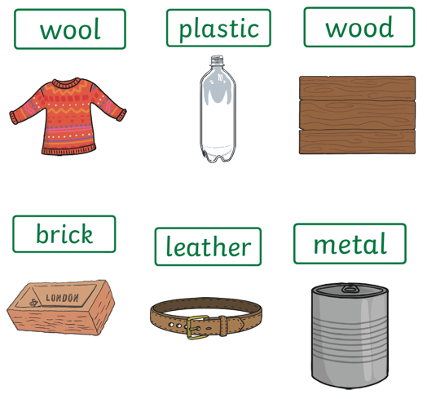

History To know about toys from the past and how they compare to modern toys.

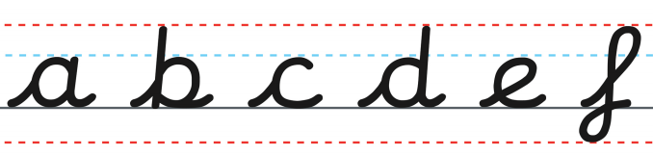

Computing

Maze Explorers.

Understanding the purpose and

how to use the direction keys.

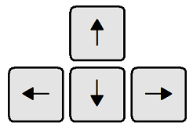

PSHE

**Living in the wider world**: Belonging to a community.

RE

Judaism - Shabbat

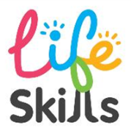

**Tying own** **laces** – especially important to reduce close contact between child/adult in school.

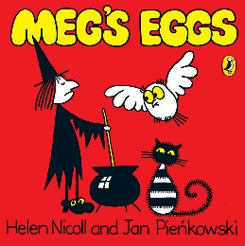

Our author is …

Helen Nicoll