THE HELPING HAND SCHOLAR GREEN NEWSLETTER
I can’t believe it’s February already! I do hope you are all doing okay and have enjoyed all the snow. I bet there were some fabulous snowmen. It’s Children’s Mental Health Week from 1st Feb. Please take a look at the resources I have added to the website under Emotional Health: Mental Health Week. Take care and I really hope to see you soon. Mrs Ashworth xx jashworth@scholargreen.cheshire.sch.uk
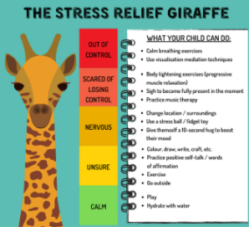
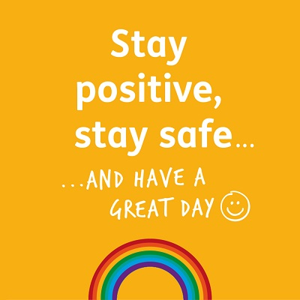
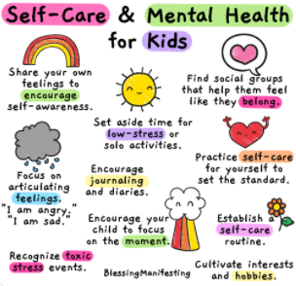

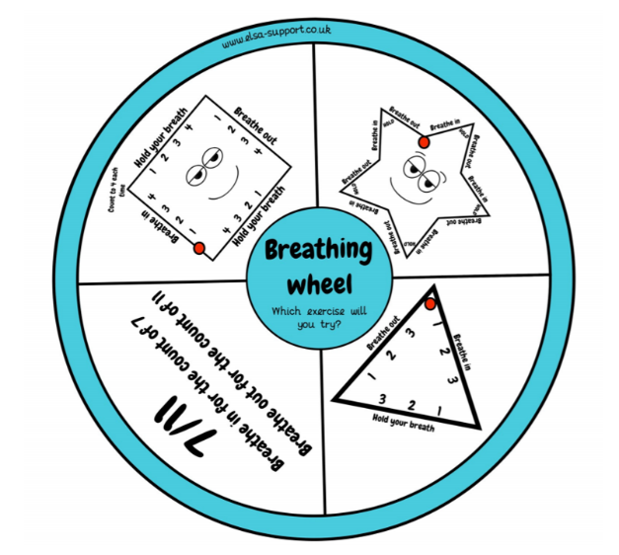
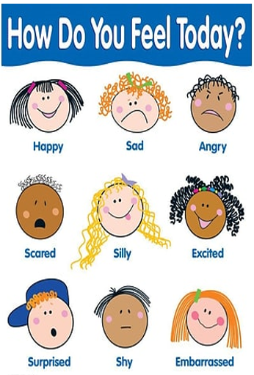
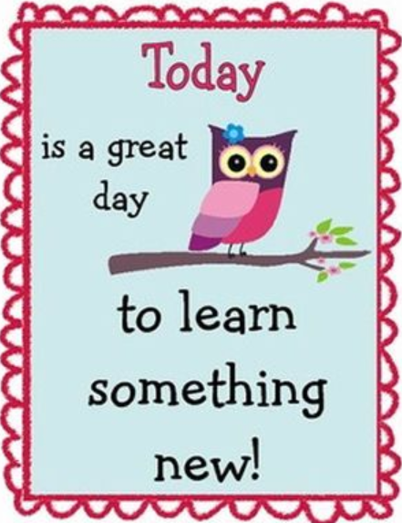
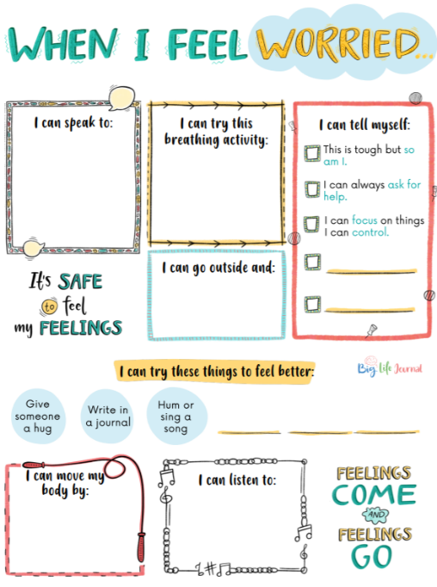
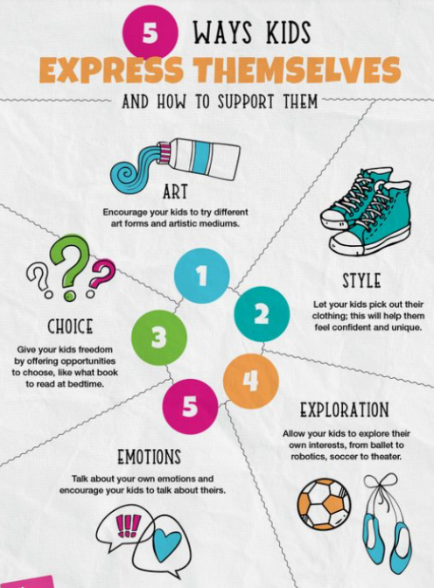
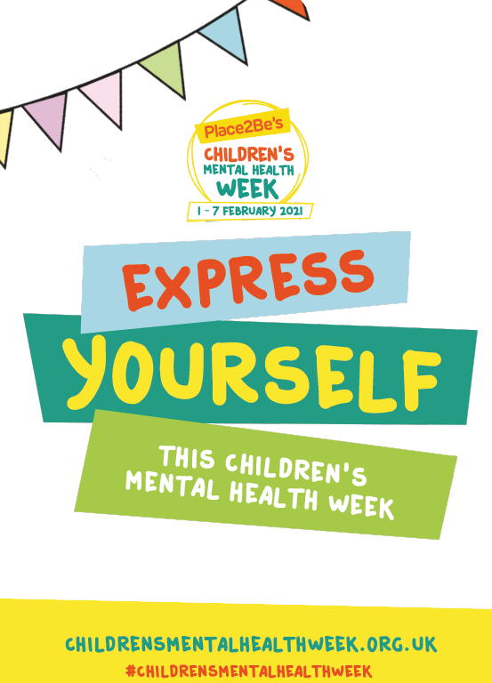
https://youtu.be/PEBURwEL9HM a link to a message from the Duchess of Cambridge. Some useful websites: www.mymind.org.uk www.youngminds.org.uk www.youinmind.org www.minded.org.uk www.childrensmentalhealthweek.org.uk

