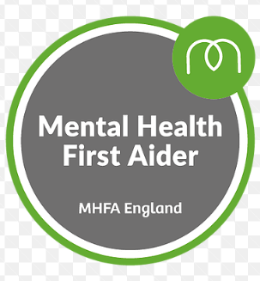
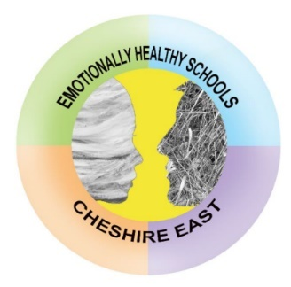

Hello, I would like to introduce myself. My name is Mrs Ashworth and my role within Scholar Green Primary School is Mental Health Lead and Deputy Safeguarding Lead.
I am passionate about my role within Scholar Green Primary School and the emotional health and well-being of the pupils, staff and parents.
I have completed the Advanced Mental Health Lead Accreditation, a 3 day Mental Health First Aider course and am an ELSA (Emotional Literacy Support Assistant) after completing a year long course.
I work with pupils on a one-to-one basis or in small group sessions and have daily ‘check-ins’ with a number of pupils. I am available to all pupils within Scholar Green who sometimes just need to sit and chat. We have a quiet room and a sensory room available to use too. No worry is too small and sharing that worry is sometimes all you need to be able to carry on your day and know that there is someone who will listen and try to help.
Every classroom has a daily check in wall so we know how everyone is feeling and know if they need a check in.
Hope you like my portrait, drawn by a pupil. I love it!
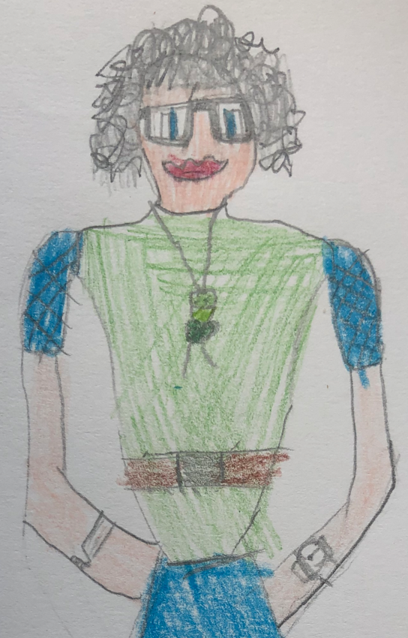
At Scholar Green Primary School, we aim to promote positive Mental Health for every member of our school community including, staff, pupils and families. We pursue this aim using both universal, whole school approaches and specialised, targeted approaches aimed at vulnerable pupils.
In addition to promoting emotional resilience and positive mental health, we aim to recognise and respond to mental ill health. By developing and implementing practical, relevant and effective mental health policies and procedures we can promote a safe and stable environment for pupils affected both directly and indirectly by mental ill health.
Each pupil and their well- being is unique and is approached in this way depending on the situation.
- In some circumstances just talking and listening is required.
- Others may benefit from a more structured programme.

Mrs Ashworth is available at all times for pupils/ staff and parents.

Here at Scholar Green Primary School we have recently been awarded for the second time The AcSEED Award. This is a recognised award and ensures that wellbeing initiatives are well structured and supported and that the school promotes a whole school approach to emotional well being and mental health support.

Lead Members of Staff
Whilst all staff have a responsibility to promote the emotional resilience, wellbeing and positive mental health of pupils, staff with a specific, relevant remit include:
- Lyndsey Colman- Designated child protection / Safeguarding Lead
- Jayne Ashworth- Mental health and wellbeing lead / ELSA / Safeguarding Deputy
- Caroline Yarwood- SENCO / Safeguarding Deputy
- Jayne Ashworth- Lead first aider
- Lyndsey Coleman- CPD lead
- Linda Hope- Head/Lead of PSHE
- Linda Hope- Head/Lead of SMSC

Please take the time to look at the Support/Website page which includes lots of useful sites for parents and children and remember the Well Being Newsletter which will be available every term.
Thanks for reading!
Mrs Ashworth

