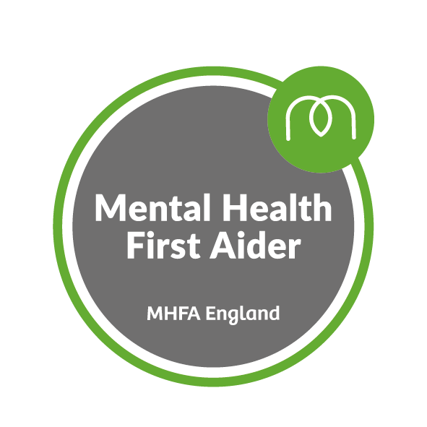

Mrs Ashworth has completed the Mental Health First Aider Course
The role of the Mental Health First Aider
Mental Health First Aid (MHFA) is an internationally recognised training course, designed to teach people how to spot the signs and symptoms of mental ill health and provide help on a first aid basis. In the same way as learning physical first aid, MHFA teaches people how to recognise those crucial warning signs of mental ill health and feel confident to guide someone to appropriate support. Embedding MHFA training within any organisation or community also encourages people to talk more freely about mental health, reducing stigma and creating a more positive culture.
Outcomes and benefits
The course will: −
- Give a deeper understanding of the issues that impact on and relate to people’s mental health
  - Teach practical skills that can be used every day, including being able to spot the signs and symptoms of mental health issues and feel confident guiding people towards support

Independent research and evaluation shows that taking part in an MHFA course: −

  - Raises awareness and mental health literacy
  - Reduces stigma around mental health
  - Boosts knowledge and confidence in dealing with mental health issues
  - Promotes early intervention which enables recovery

