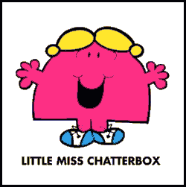
Chatter Box Challenge
A lot of our first half term will be about getting to know each other; our likes, dislikes, what we enjoy playing with and what makes us happy!

In between now and when we begin school in September, we would like you to create a ‘Chatter box’. You can use an old box, such as a shoe box, decorate it so that you know that it is yours, and fill it with things about you.
Possible Chatter Box items:
- A souvenir from a holiday
- Leaflets from placed visited
- Photographs of your family and your home
- Special objects that mean something to us
- Anything that you might like to share with your new class friends that tells us a little bit about you.
Happy Chattering!

Postcard challenge
We would love to hear about what you are getting up to during the summer holidays, so we would like you to send a postcard to us from somewhere that you go on holiday or visit for the day. We would like to display all of your postcards ready for when you start school.
Our address is:
Scholar Green Primary School
Congleton Road North,
Scholar Green,
Stoke-On-Trent,
ST7 3HF
We can’t wait to see where you have been.

